**UNIT – I: MULTIPLE INTEGRALS**

***PART A***

***MULTIPLE CHOICE QUESTIONS***

1. Evaluation of 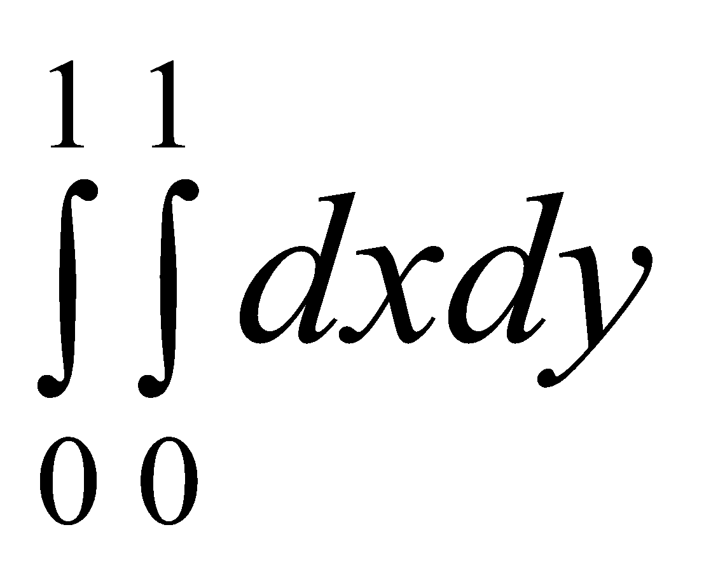 is

a) 1 b) 2 c) 0 d) 4

1. The curve 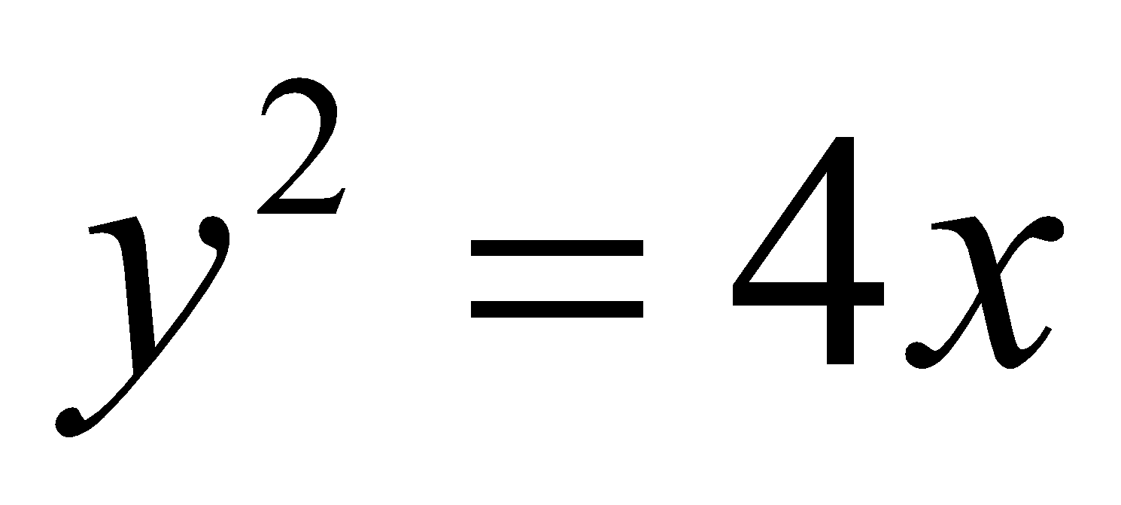 is a

a) parabola b) hyperbola c) straight line d) ellipse

1. Evaluation of 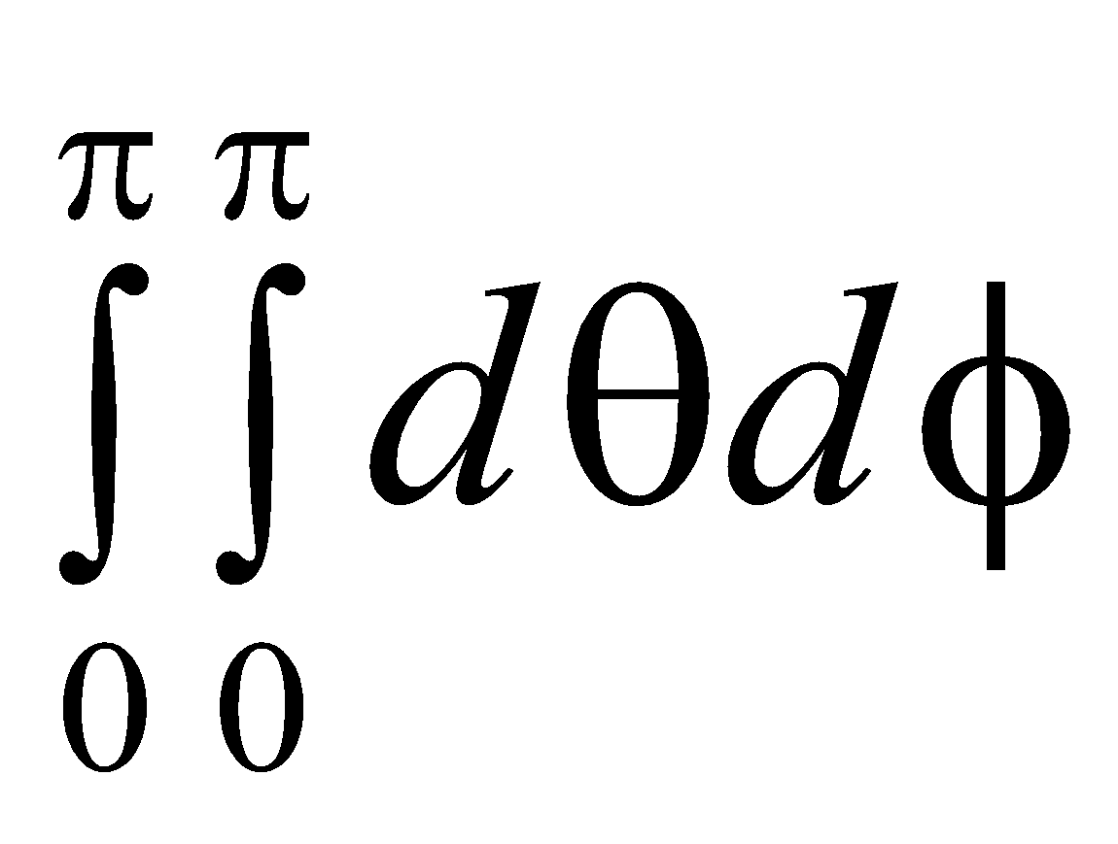 is

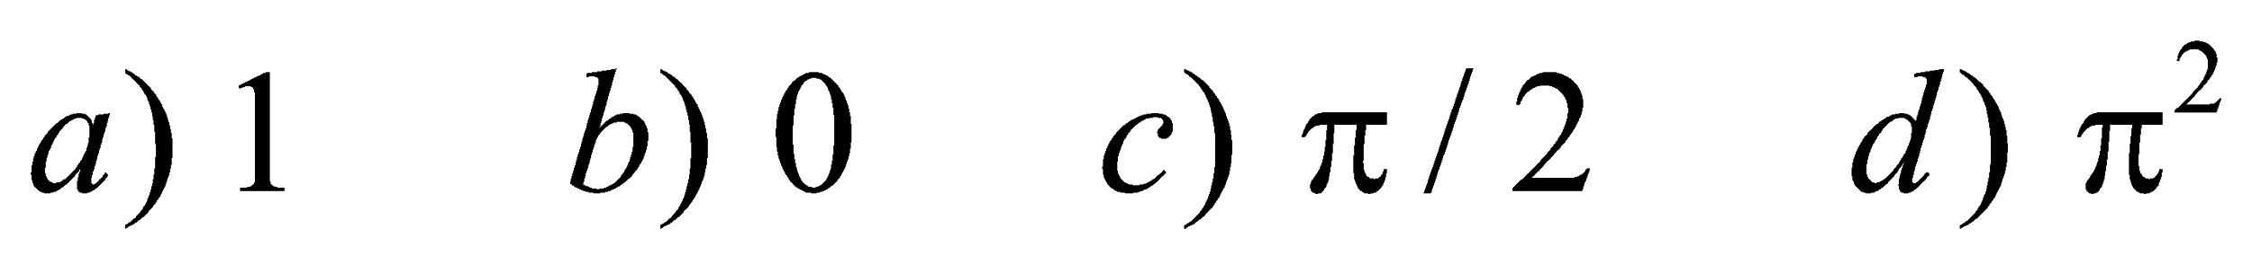

1. The area of an ellipse is



1. 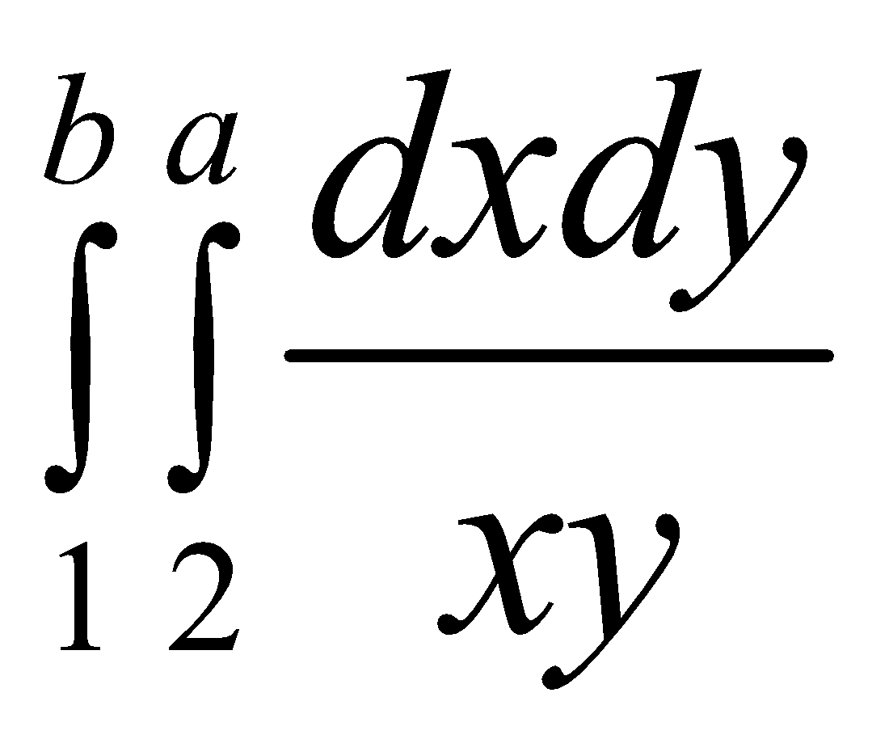 is equal to

a) loga + logb b) loga c) logb d) loga logb

1. 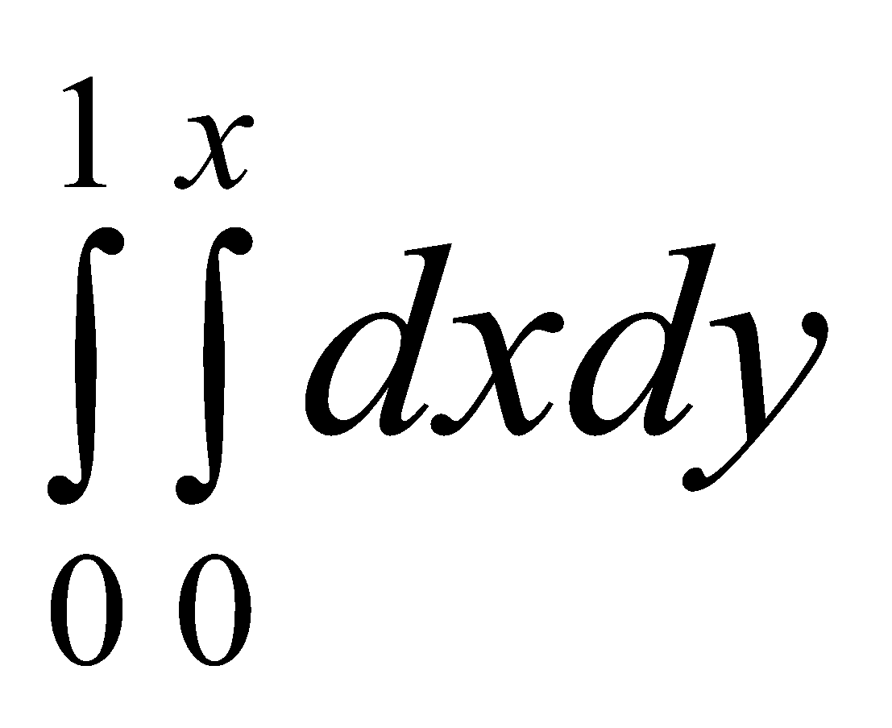 is equal to

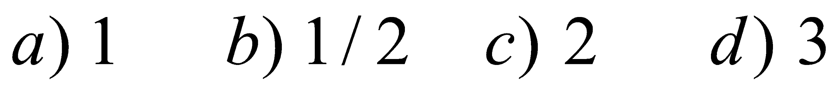

1. 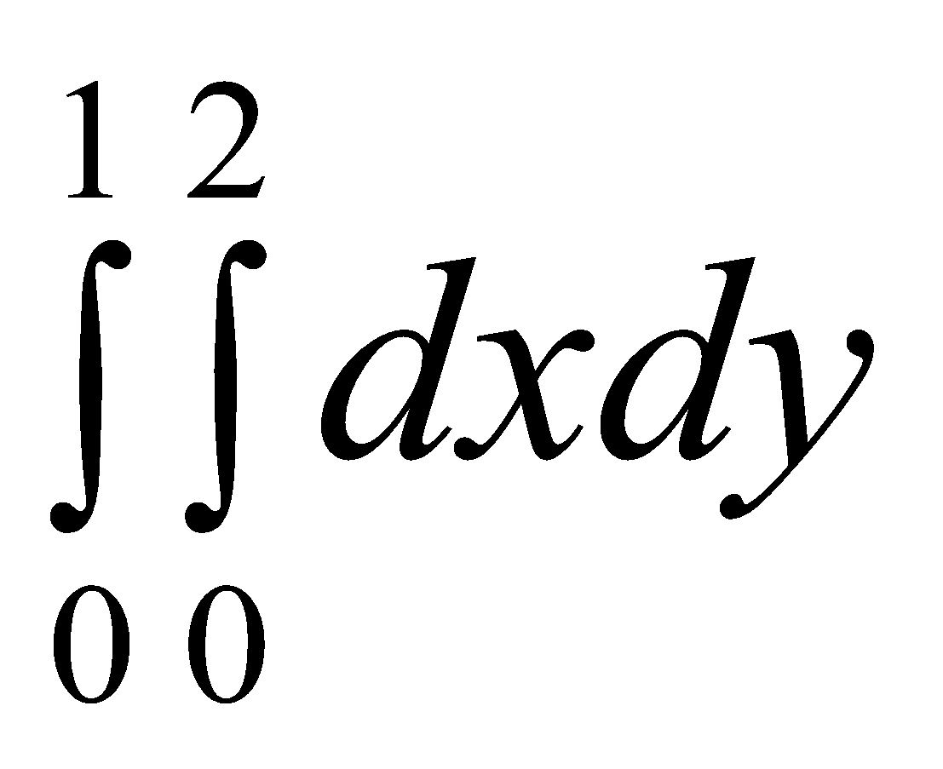 is equal to

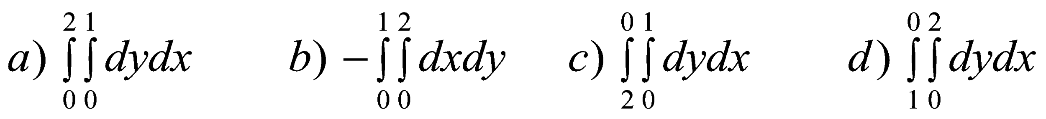

1. If R is the region bounded x = 0, y = 0, x + y = 1 then 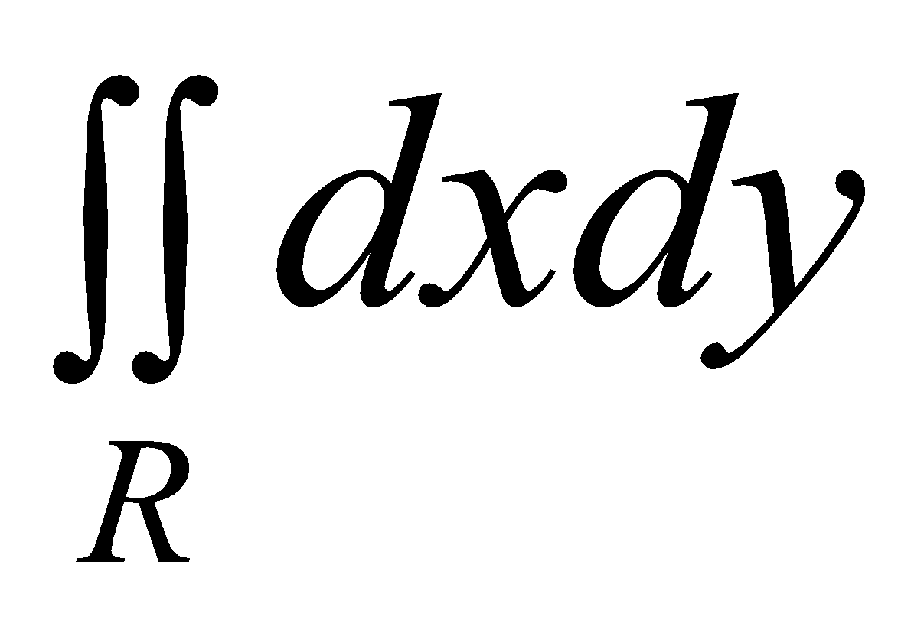 is equal to



1. Area of the double integral in Cartesian co-ordinate is equal to



1. Change the order of integration in 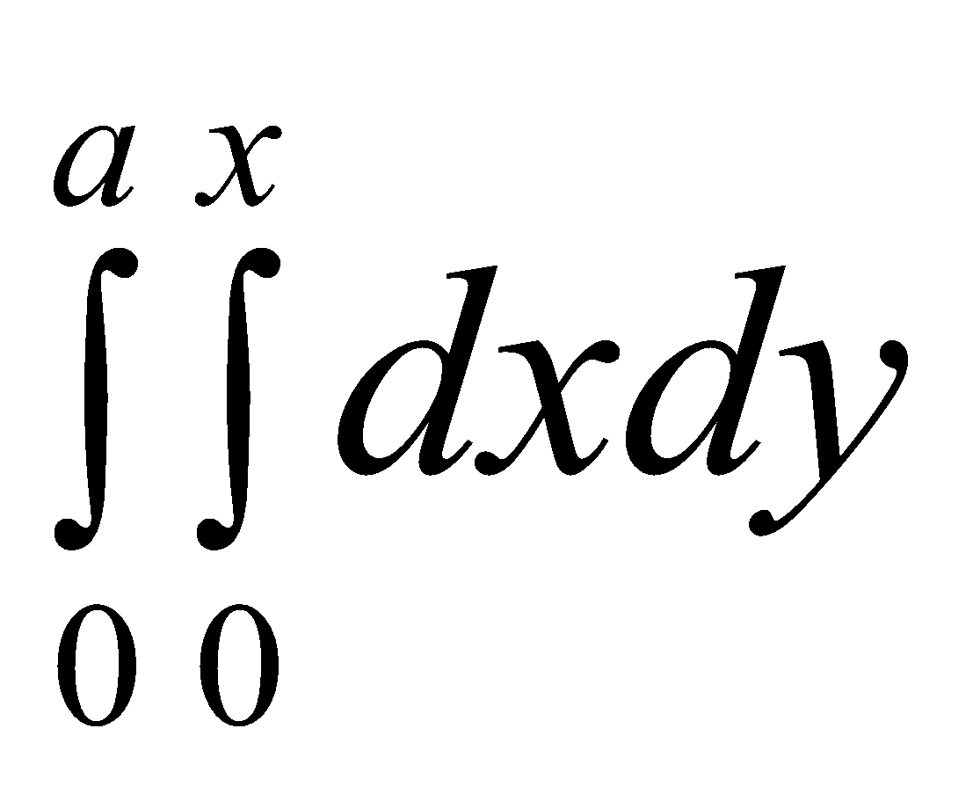 is

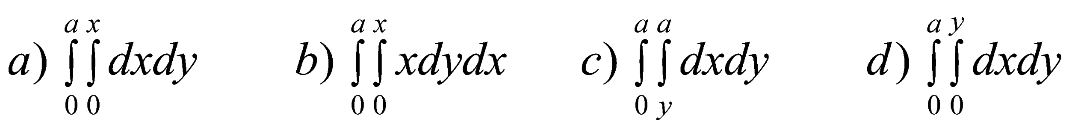

1. Area of the double integral in polar co-ordinate is equal to



1. 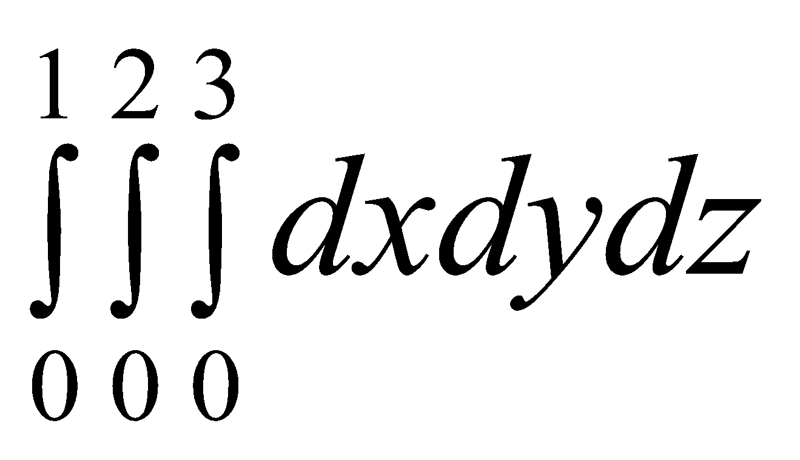 is equal to

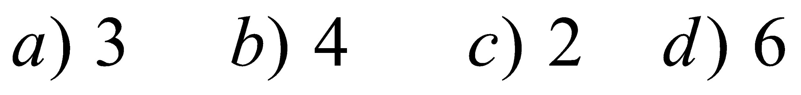

1. The name of the curve 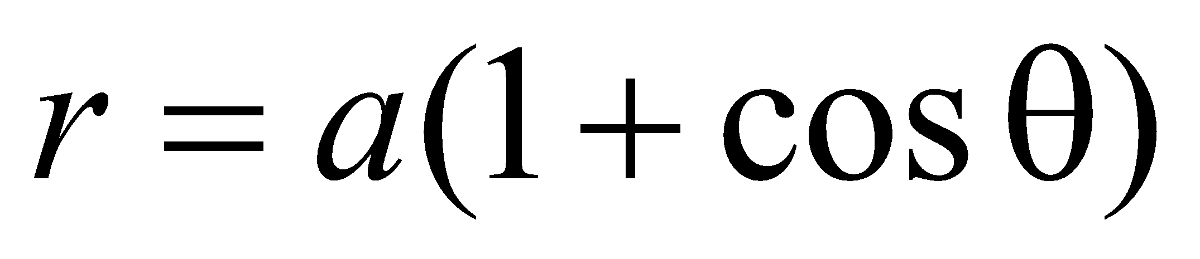 is

a) lemniscates b) cycloid c) cardioids d) hemicircle

1. The volume integral in Cartesian coordinates is equal to



1. 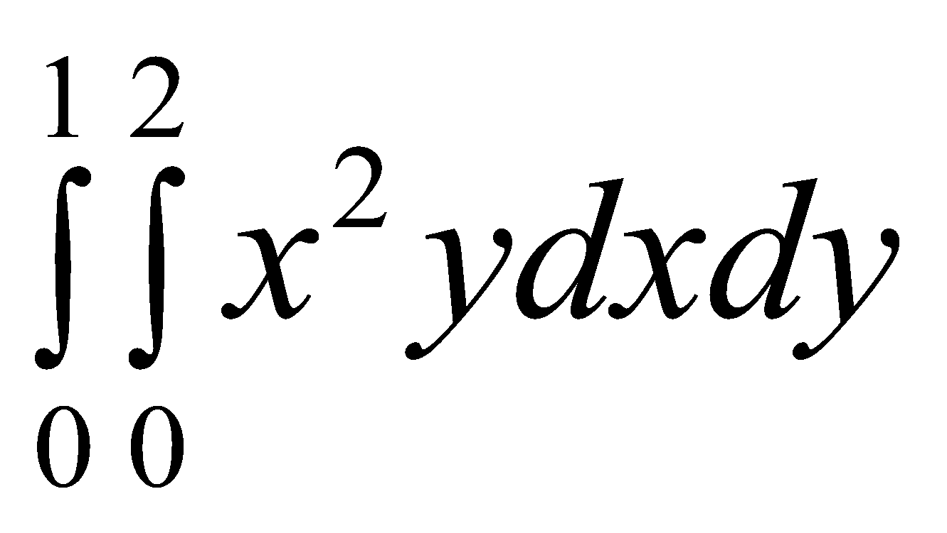 is equal to

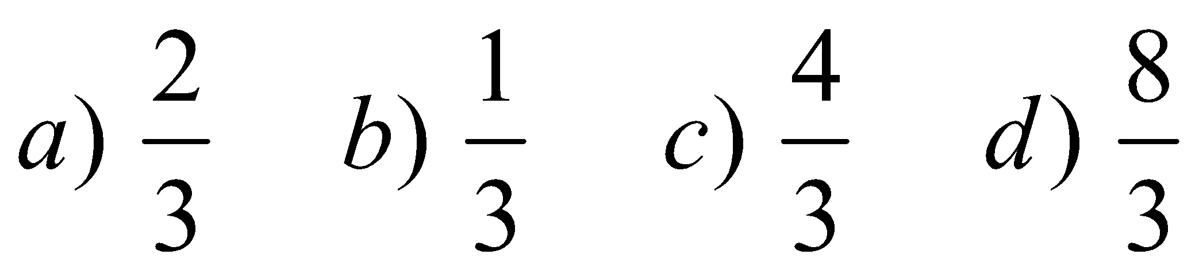

1. 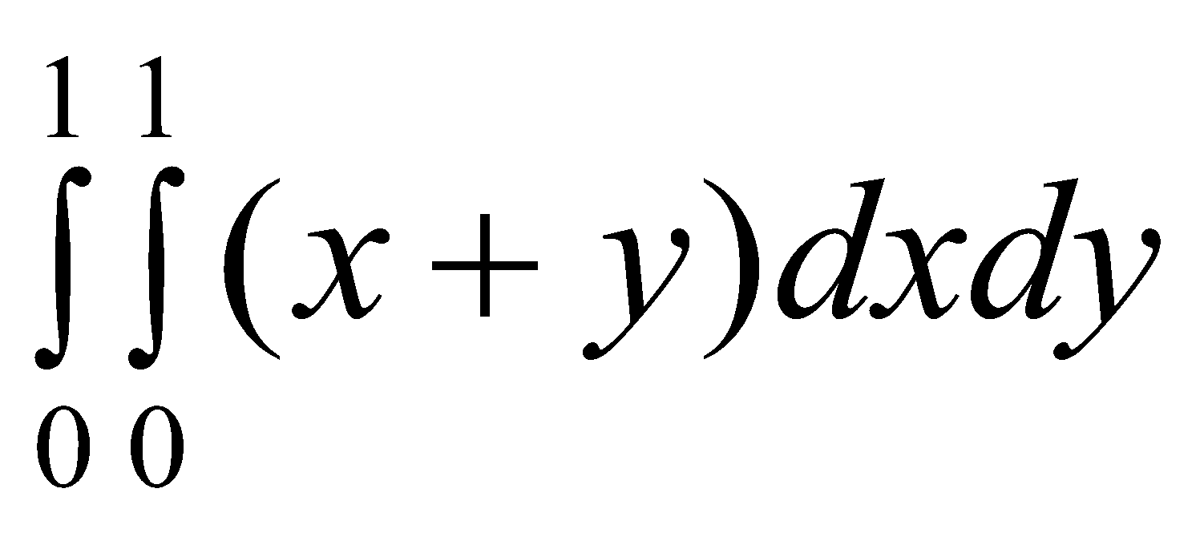 is equal to

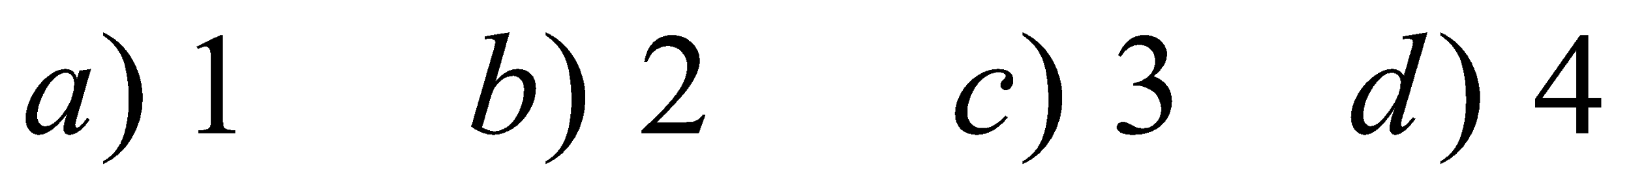

1. In polar the integral 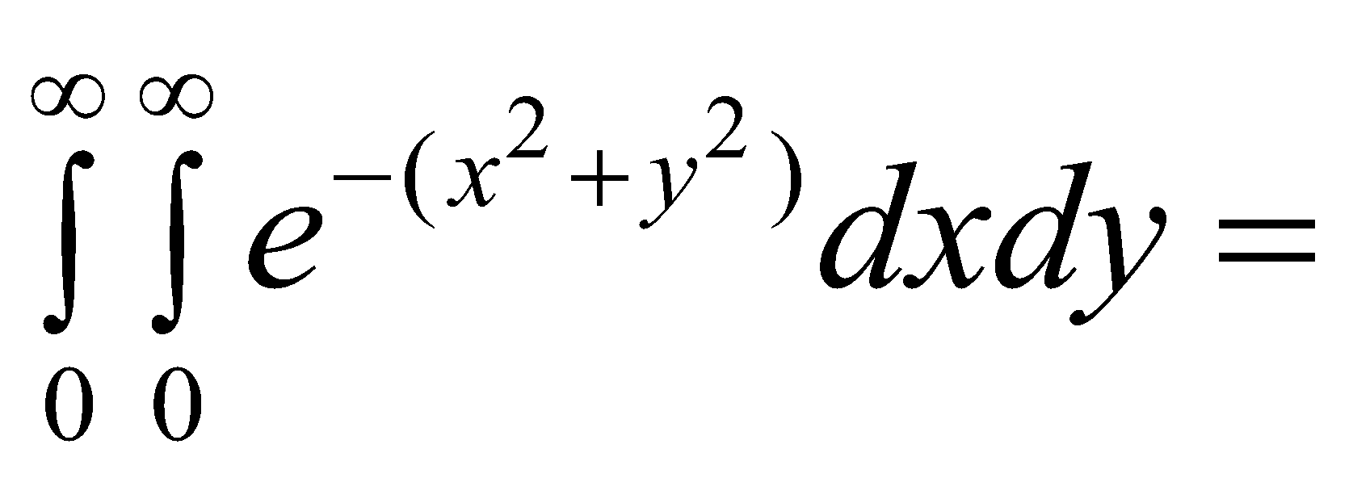



1. 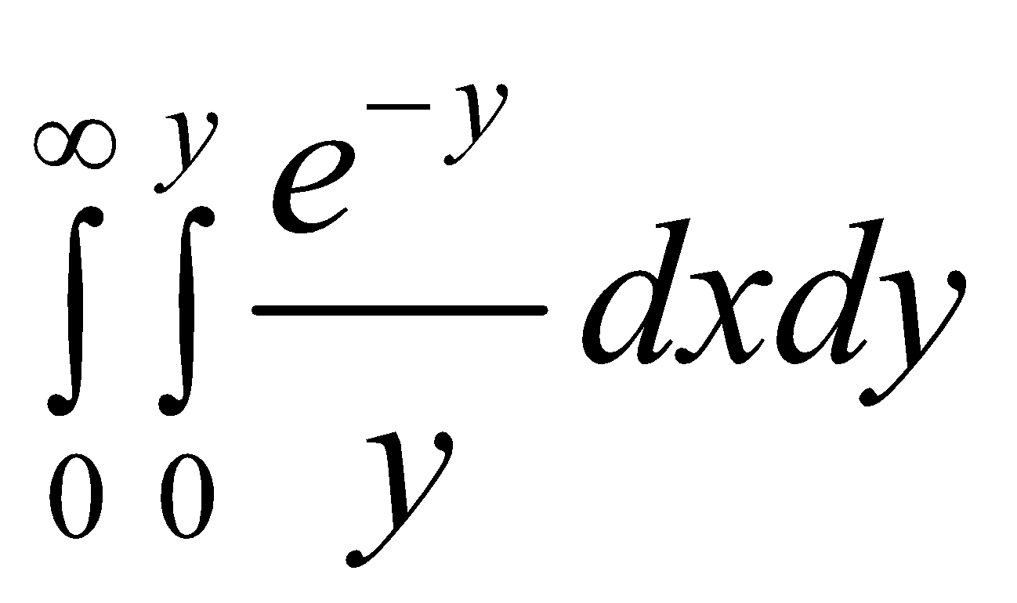is equal to

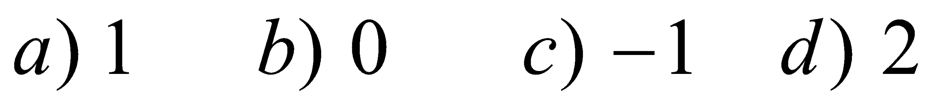

1. In the double integral other than integral is called

a) Variable b) Separable c) Constant d) Multiple

1. Changing the order of integration in the double integral based on

a) limits b) function c) region d) order

1. The value of the integral 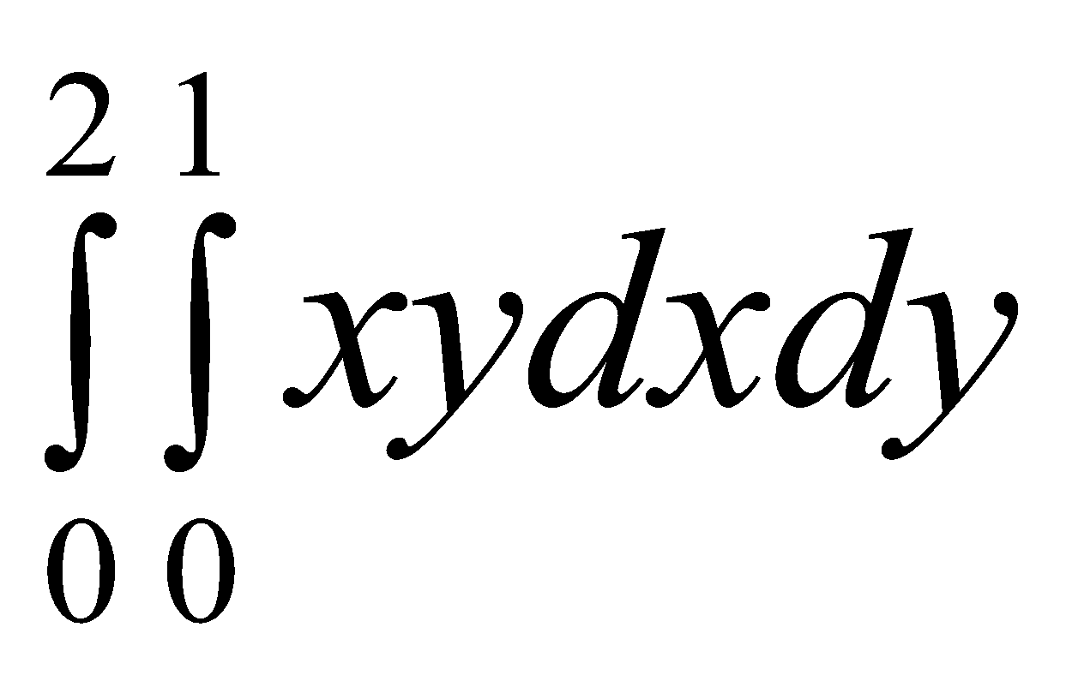 is

(a) 1 (b) 2 (c) 3 (d) 4

1. The value of the integral 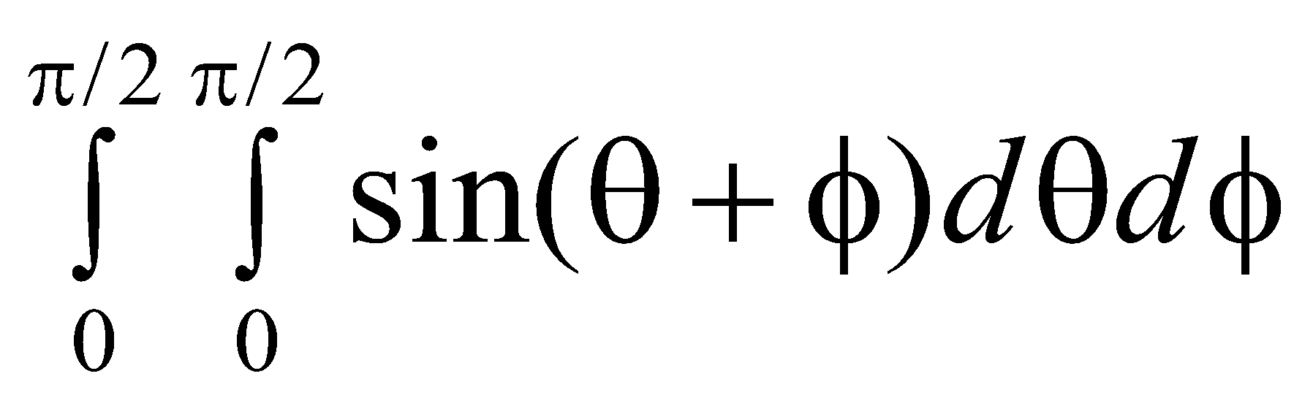

(a) 1 (b) 2 (c) 3 (d) 4

1. The region of integration of the integral 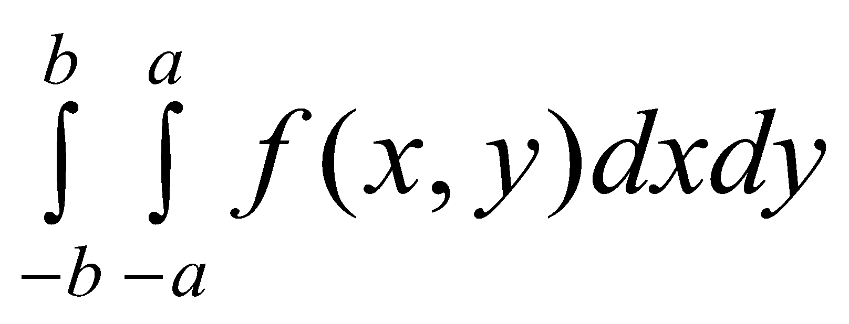 is

(a) square (b) circle (c) rectangle (d) triangle

1. The region of integration of the integral 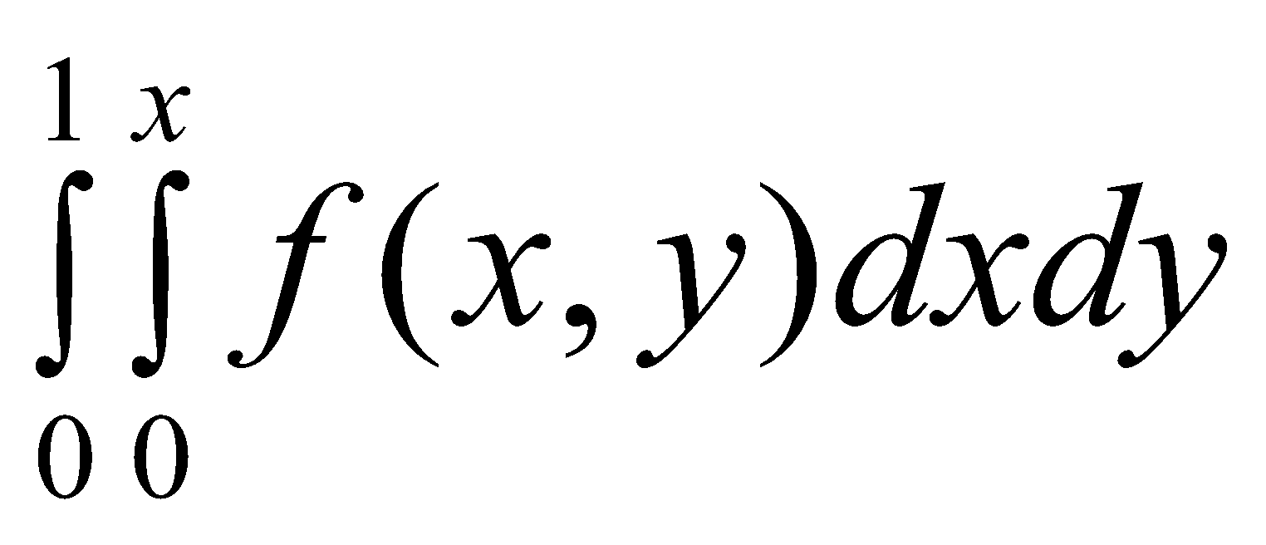 is

(a) square (b) rectangle (c) triangle (d) circle

1. The limits of integration is the double integral 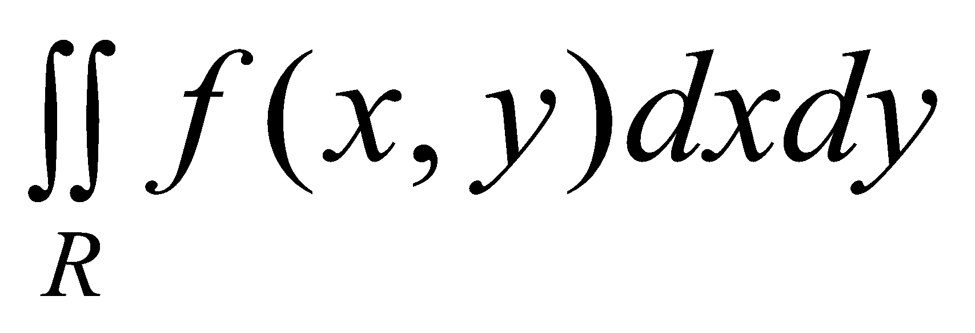, where R is in the first quadrant and bounded by x = 0, y = 0, x + y = 1 are

